**Note:** *Include this page only when adding / amending / deleting a document. If using this document as a record, this Revision History page can be omitted.*

**REVISION HISTORY**

|  |  |  |  |  |  |
| --- | --- | --- | --- | --- | --- |
| Revision no | Date | Description of Changes | Reason for Revision | Revised by | Approved by |
| 0 | February 2, 2017 | Created the document. | Serve as a guide in updating the GENIISYS Business Processes | GCMiralles |  |
|  |  |  |  |  |  |
|  |  |  |  |  |  |
|  |  |  |  |  |  |
|  |  |  |  |  |  |
|  |  |  |  |  |  |

1. **Objective**
2. To provide a guide on how to install the **TurtoiseSVN** and update the GENIISYS Business Process documents
3. **Responsibility**
4. Analyst
5. **References**
6. **Table of Contents**
7. Installing Turtoise SVN
8. Checkout existing GENIISYS Business Processes
9. How to update existing GENISYS Business Processes
10. **Work Instructions**
11. Installation

Download installer from <http://tortoisesvn.net/>

Run the installer, use the default installation options

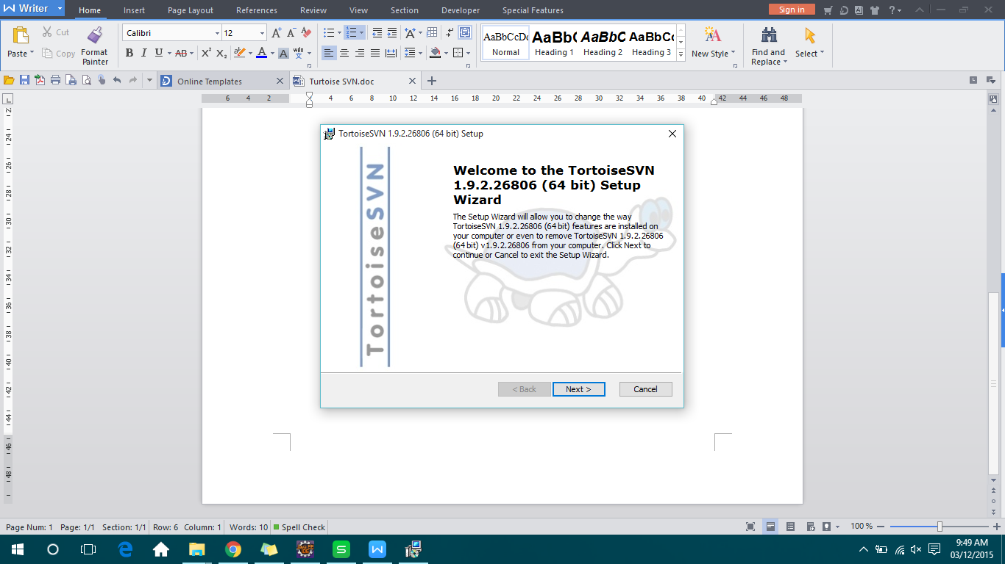

After installation, you should see the *Turtoise SVN* options in your *context menu* (right-click).

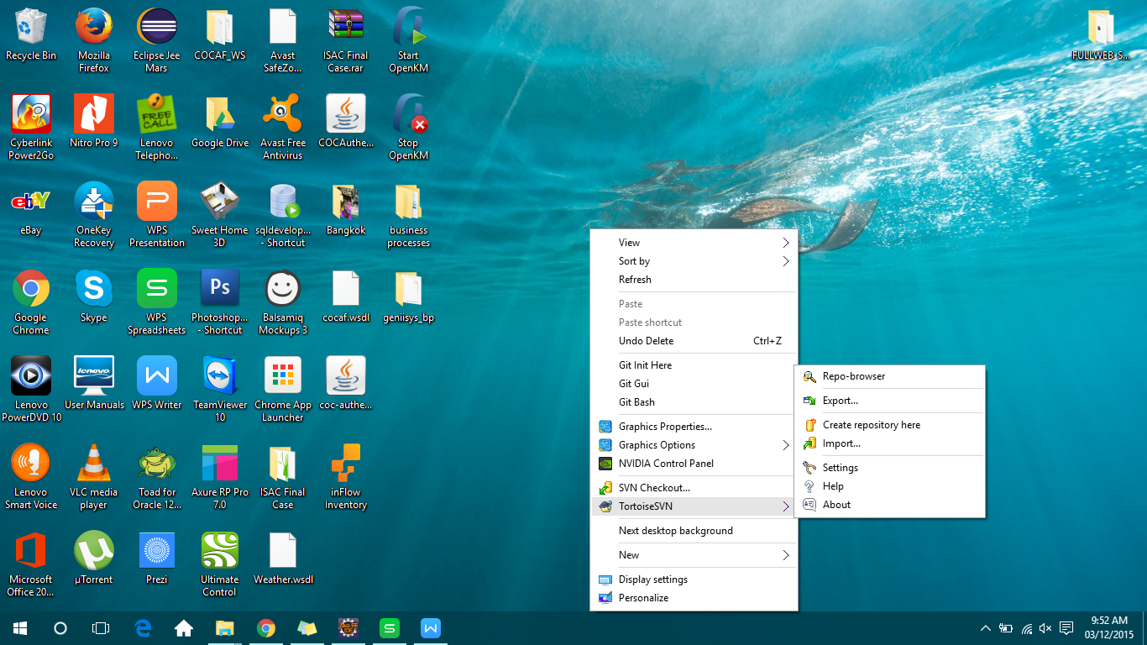

1. Check-out

Select a work space folder where you want to copy the business process documents.

Right-click inside the folder, select *SVN Checkout* menu.

Enter <https://subversion.assembla.com/svn/geniisys-br-docs/trunk/> in the URL field.

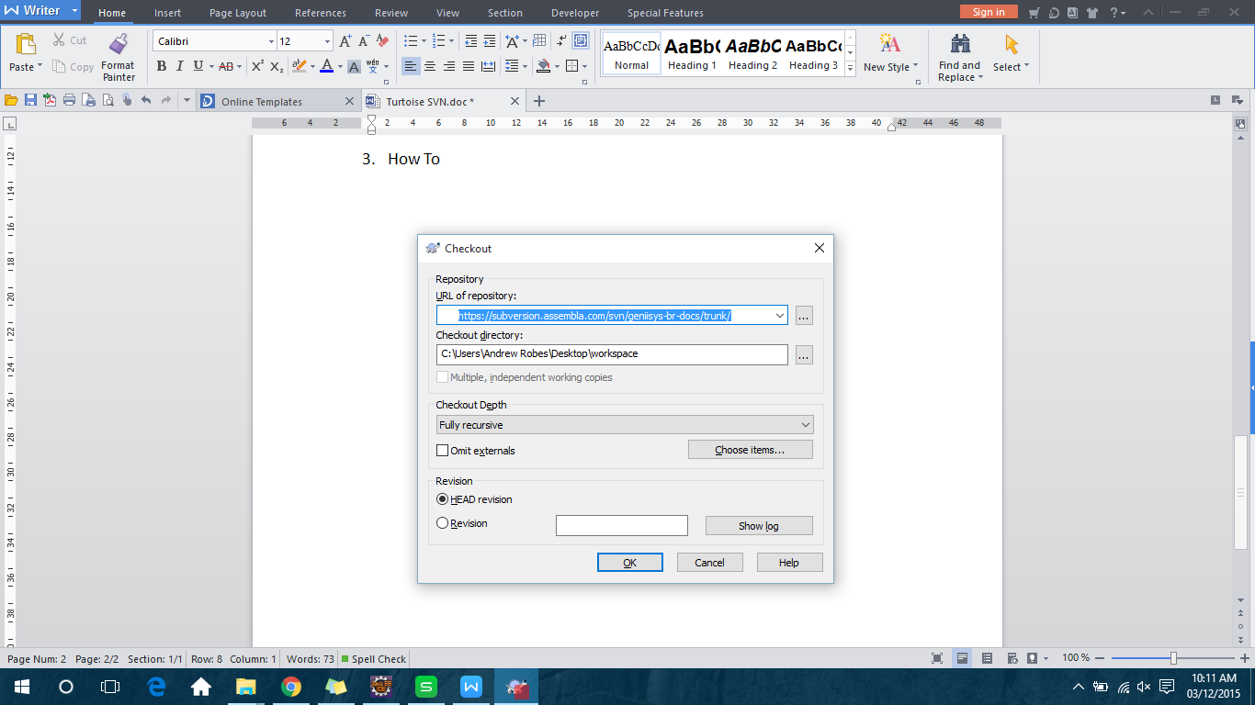

Press OK button and wait for check-out to complete.

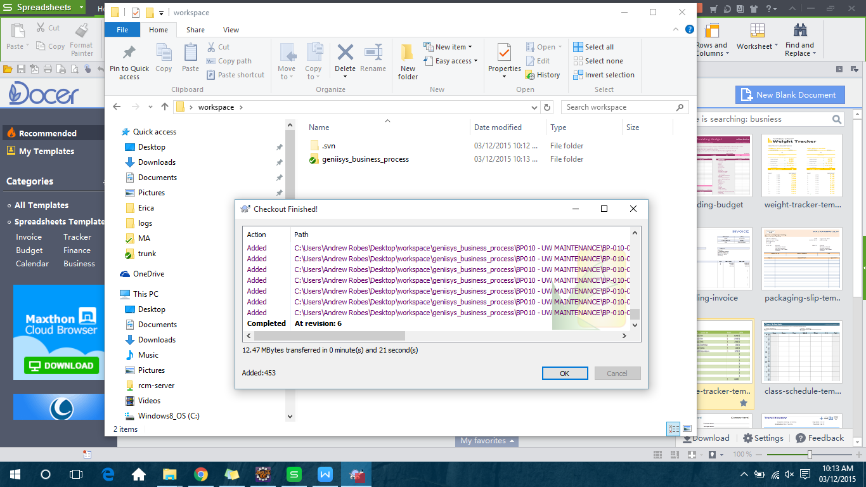

1. How to update GENIISYS Business Processes

**Update** - right-click on your work space folder or the *geniisys_business_process* folder, select *SVN Update* menu.

**Commit** - right-click on your work space folder or the *geniisys_business_process* folder, select *SVN Commit* menu. Enter comments and review the files in the commit window.

SR Number: KB Task Number:

Reviewed by: Approved by:

Remarks: (N-New BP, C-Change BRs of existing BP, A-Add BRs to existing BP, D-Delete of existing BP)

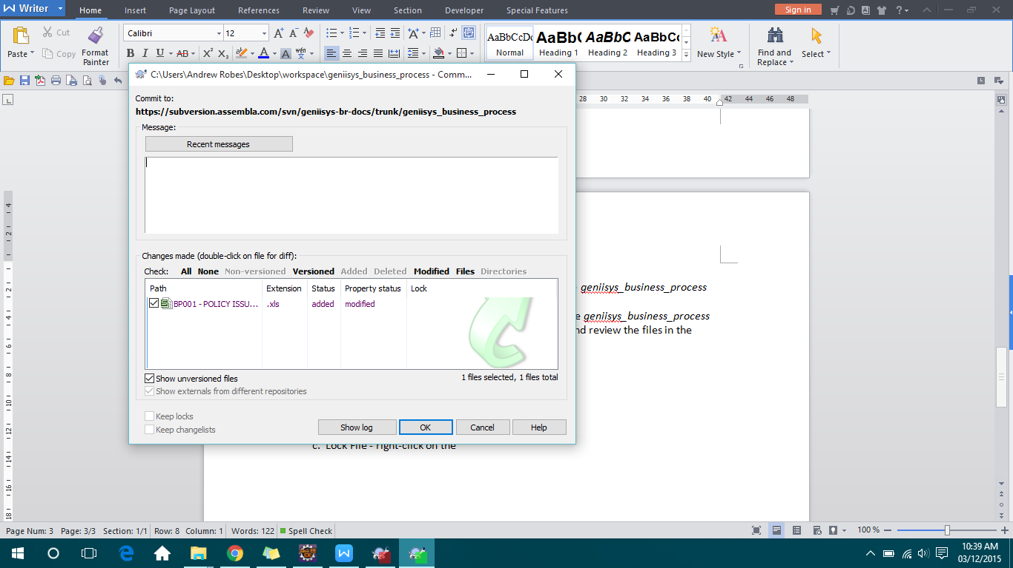

Notes:

- 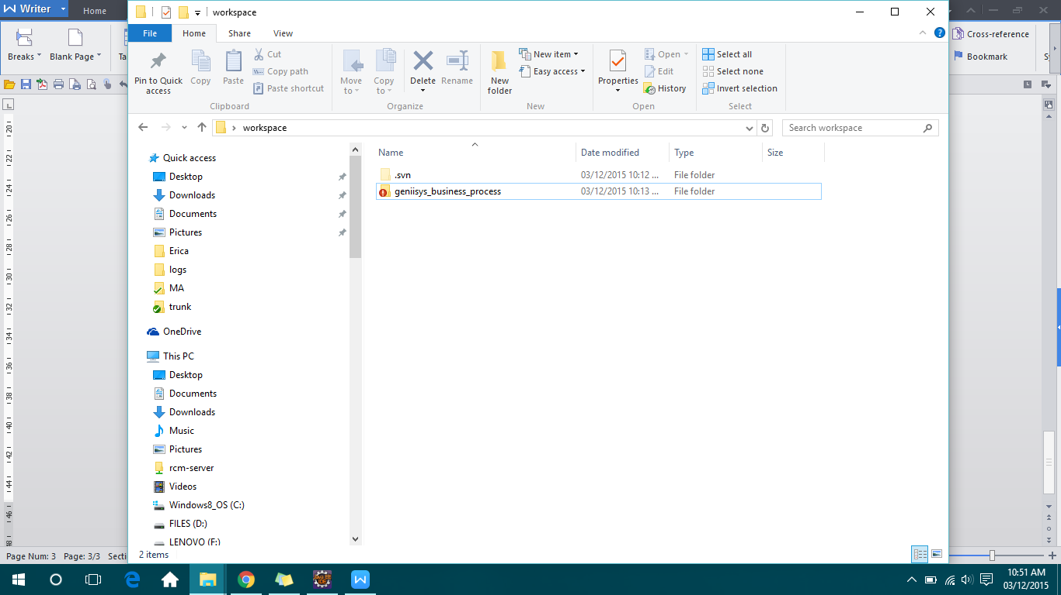 Red exclamation icon means you have local changes which are not committed to repository.

- 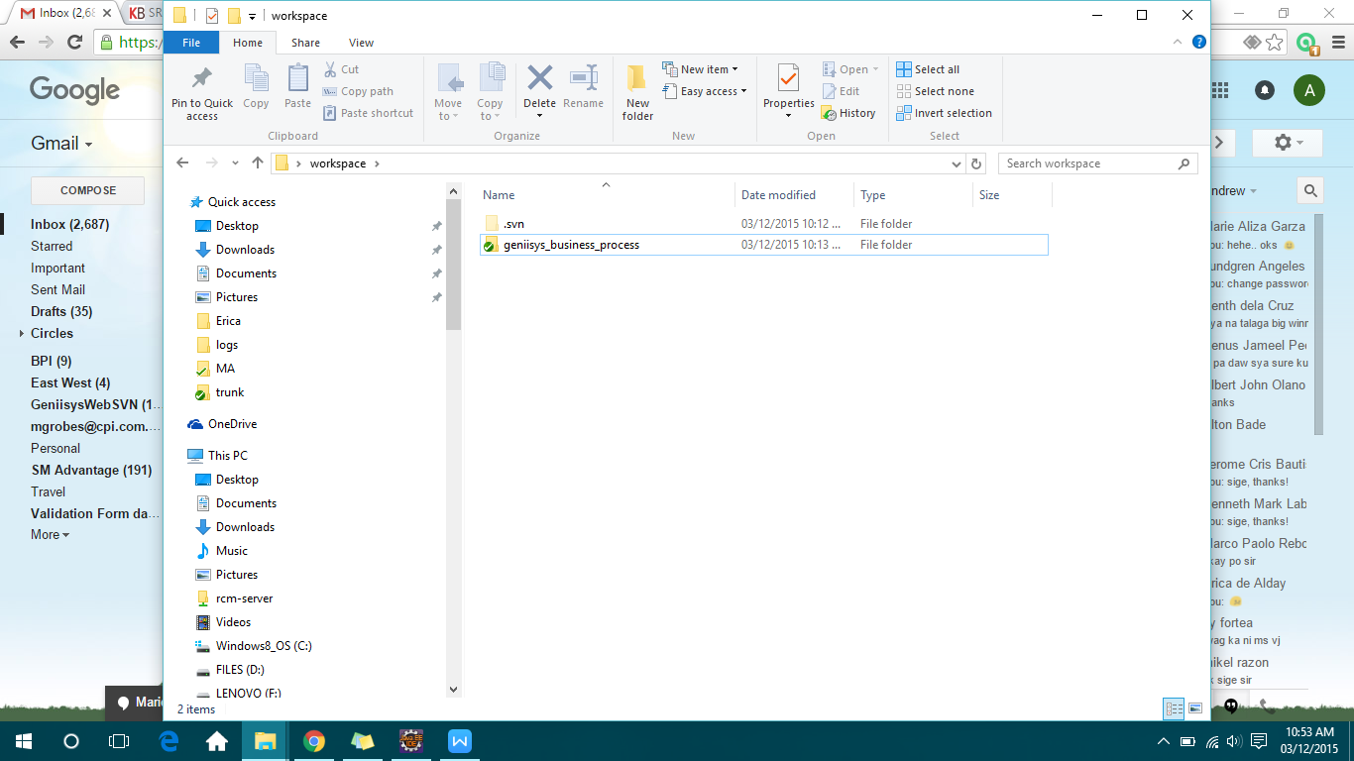 Green check icon means you don’t have local changes but you still need to update your local copy every time.

**Revert Local Changes** - right-click on specific file/s or folder, select *TurtoiseSVN -> Revert*.

**Lock File** - right-click on the file/s, select *Get Lock.*

**Unlock File** - right-click on the file/s, select *Release Lock.*

**Add New File** - after creating new local file, *select the file -> right-click -> TurtoiseSVN -> Add* then *Commit* the file.